Name of Journal: World Journal of Gastroenterology
Manuscript NO:
Manuscript Type: EDITORIAL

Baishideng’s Reference Citation Analysis database announces the first Journal Article Influence Index of 101 core journals in gastroenterology and hepatology

Wang JL et al. RCA announces 2022 JAII of 101 journals in gastroenterology and hepatology

Jin-Lei Wang, Lian-Sheng Ma

Jin-Lei Wang, Lian-Sheng Ma, Baishideng Publishing Group Inc, Pleasanton, CA 94566, United States

Author contributions: Wang JL analyzed the data and drafted the manuscript; Ma LS revised the manuscript for important intellectual content.

Corresponding author: Lian-Sheng Ma, Founder, CEO, Baishideng Publishing Group Inc, 7041 Koll Center Parkway, Suite 160, Pleasanton, CA 94566, United States. l.s.ma@baishideng.com

Abstract
After three rounds of rigorous evaluation on core journals in gastroenterology and hepatology conducted by the Reference Citation Analysis (RCA) editorial team of Baishideng Publishing Group (Baishideng), the RCA database of Baishideng officially released the 2022 Journal Article Influence Index (2022 JAII) of 101 core journals in gastroenterology and hepatology, for the first time. The list of 101 core journals can be found at: https://www.referencecitationanalysis.com/SearchJournal. Among them, the highest 2022 JAII is 48.014 and the lowest is 3.900. This article highlights the top 20 to describe the calculation method for the 2022 JAII, the evaluation process itself, and the inclusion principles for journals in the RCA. These steps are the underpinning of the RCA’s empirical journal academic evaluation service by which the digital platform addresses the needs of authors to select reliable journals for submission, readers to select high-quality literature for reading, and editors to track their own journal citation performance. As such, the RCA core journal list will serve as a useful Find-a-Journal tool. Any interested party is welcome to use this journal list and recommend it to their peers.

Key Words: Reference Citation Analysis; Journal Article Influence Index; Gastroenterology and hepatology; Journal list; Find a journal; Announcement

Wang JL, Ma LS. Baishideng’s Reference Citation Analysis database of announces the first Journal Article Influence Index of 101 core journals in gastroenterology and hepatology. World J Gastroenterol 2022; In press

Core Tip: The Reference Citation Analysis (RCA) database of Baishideng Publishing Group officially released the 2022 Journal Article Influence Index (2022 JAII) of 101 core journals in gastroenterology and hepatology, for the first time. This article highlights the top 20 among these to describe the calculation method of 2022 JAII, evaluation process and inclusion principles. The RCA journal academic evaluation service platform addresses the needs of authors to select reliable journals for submission, readers to select high-quality literature for reading, and editors to track their own journal citation performance, effectively serving as a useful Find-a-Journal tool. You are welcome to use this journal list and recommend it to your peers.

INTRODUCTION
Congratulations are due to the innumerable contributors who inspired and worked diligently on the Reference Citation Analysis (RCA) database of Baishideng Publishing Group (Baishideng) to facilitate the first official release of the 2022 Journal Article Influence Index (2022 JAII) for journals in gastroenterology and hepatology. The total 101 core journals in gastroenterology and hepatology can be found at: https://www.referencecitationanalysis.com/SearchJournal.
RCA is an artificial intelligence technology-based open multidisciplinary citation analysis database. It was carefully designed to lead the development of wisdom, knowledge innovation, and emerging disciplines^{[1]}. As such, the functions of RCA include: Find an Article (54753299), Find a Category (274), Find a Journal (14087), Find a Scholar (631), and Find an Academic Assistant (15). RCA updates its list of journals daily, according to relevant data including total number of articles, total citations, and JAII. RCA acquires newly released abstracts and references from Crossref and adds them to the RCA database weekly. RCA also acquires abstracts and references released within the calendar year from Crossref and adds them to the RCA database monthly, and then updates the total number of articles, citations, and JAII accordingly.
Herein, we introduce the top 20 2022 JAII from among the total 101 core journals in the field of gastroenterology and hepatology included in RCA, in order to describe the calculation method of 2022 JAII, the evaluation process and the inclusion principles of RCA journals.

TOP 20 2022 JAII JOURNALS INCLUDED IN RCA
2022 JAII and rankings of Seminars in Liver Disease
In the RCA database, the 2022 JAII for Seminars in Liver Disease is 48.014, ranking 1st among 101 core journals in the field of gastroenterology and hepatology included in the RCA, with total citations of 83641 (28/101) and total articles of 1742 (50/101) (Figure 1). For more information about Seminars in Liver Disease, please visit: https://www.referencecitationanalysis.com/SearchJournal.
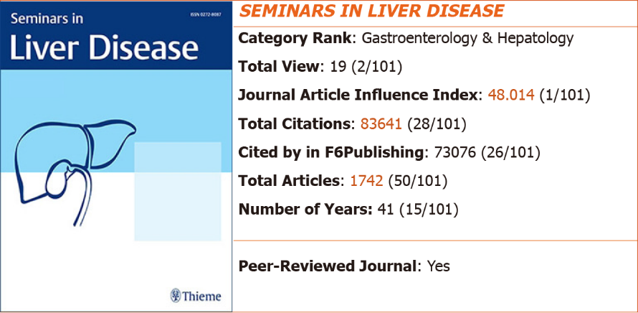
Figure 1 2022 Journal Article Influence Index and rankings of Seminars in Liver Disease.

2022 JAII and rankings of Hepatology
In the RCA database, the 2022 JAII for Hepatology is 43.054, ranking 2nd among 101 core journals in the field of gastroenterology and hepatology included in the RCA, with total citations of 1169100 (2/101) and total articles of 27154 (2/101) (Figure 2). For more information about Hepatology, please visit: https://www.referencecitationanalysis.com/SearchJournal.
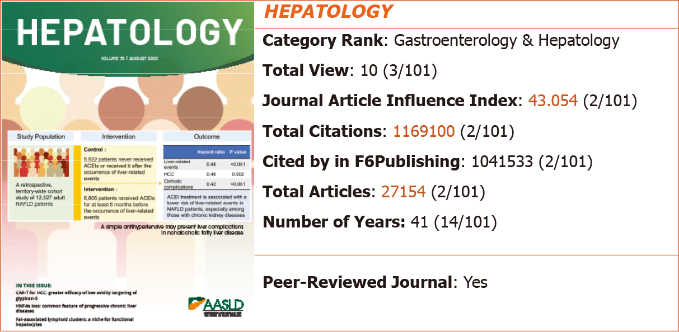
Figure 2 2022 Journal Article Influence Index and rankings of Hepatology.

2022 JAII and rankings of Gastroenterology
In the RCA database, the 2022 JAII for Gastroenterology is 37.170, ranking 3rd among 101 core journals in the field of gastroenterology and hepatology included in the RCA, with total citations of 1711173 (1/101) and total articles are 46037 (1/101) (Figure 3). For more information about Gastroenterology, please visit: https://www.referencecitationanalysis.com/SearchJournal.
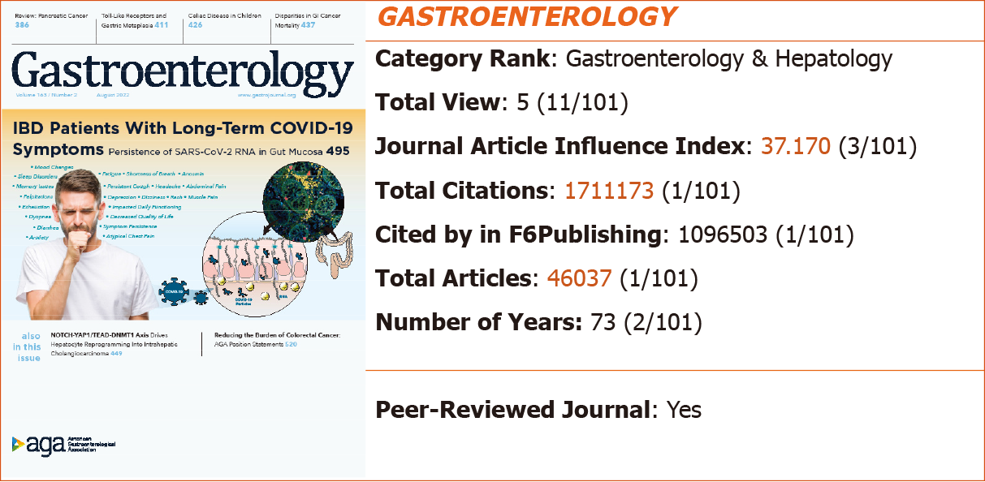
Figure 3 2022 Journal Article Influence Index and rankings of Gastroenterology.

2022 JAII and rankings of Gut
In the RCA database, the 2022 JAII for Gut is 36.751, ranking 4th among 101 core journals in the field of gastroenterology and hepatology included in the RCA, with total citations of 914769 (3/101) and total articles of 24891 (3/101) (Figure 4). For more information about Gut, please visit: https://www.referencecitationanalysis.com/SearchJournal.
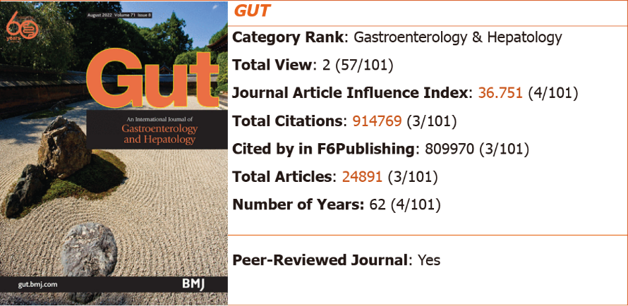
Figure 4 2022 Journal Article Influence Index and rankings of Gut.

2022 JAII and rankings of Nature Reviews Gastroenterology & Hepatology
In the RCA database, the 2022 JAII for Nature Reviews Gastroenterology & Hepatology is 35.473, ranking 5th among 101 core journals in the field of gastroenterology and hepatology included in the RCA, with total citations of 100601 (24/101) and total articles of 2836 (40/101) (Figure 5). For more information about Nature Reviews Gastroenterology & Hepatology, please visit: https://www.referencecitationanalysis.com/SearchJournal.
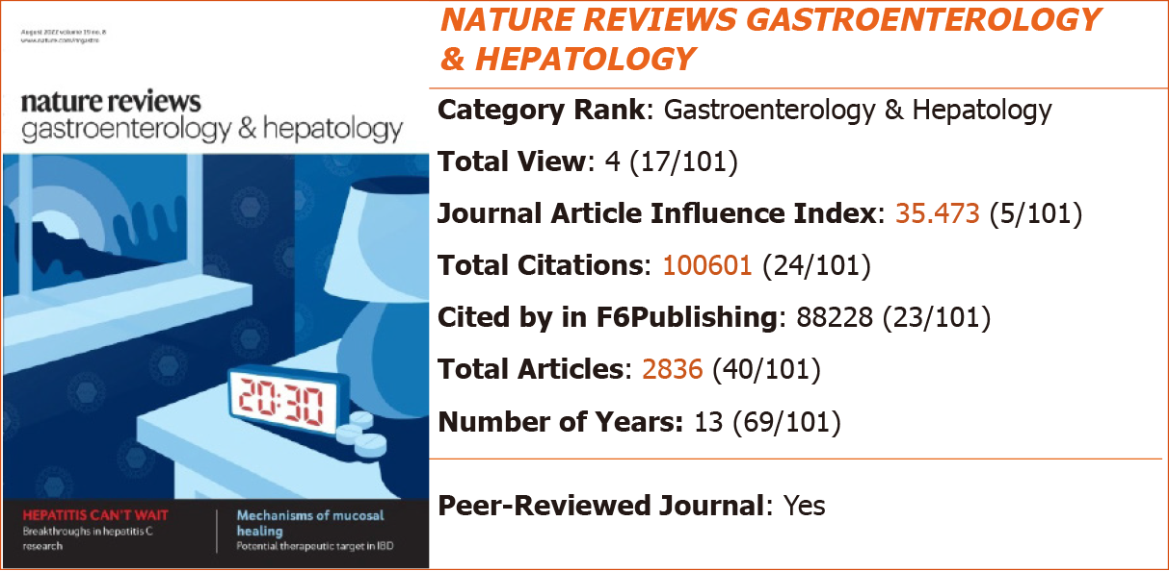
Figure 5 2022 Journal Article Influence Index and rankings of Nature Reviews Gastroenterology & Hepatology.

2022 JAII and rankings of Gut Microbes
In the RCA database, the 2022 JAII for Gut Microbes is 31.557, ranking 6th among 101 core journals in the field of gastroenterology and hepatology included in the RCA, with total citations of 38720 (41/101) and total articles of 1227 (64/101) (Figure 6). For more information about Gut Microbes, please visit: https://www.referencecitationanalysis.com/SearchJournal.
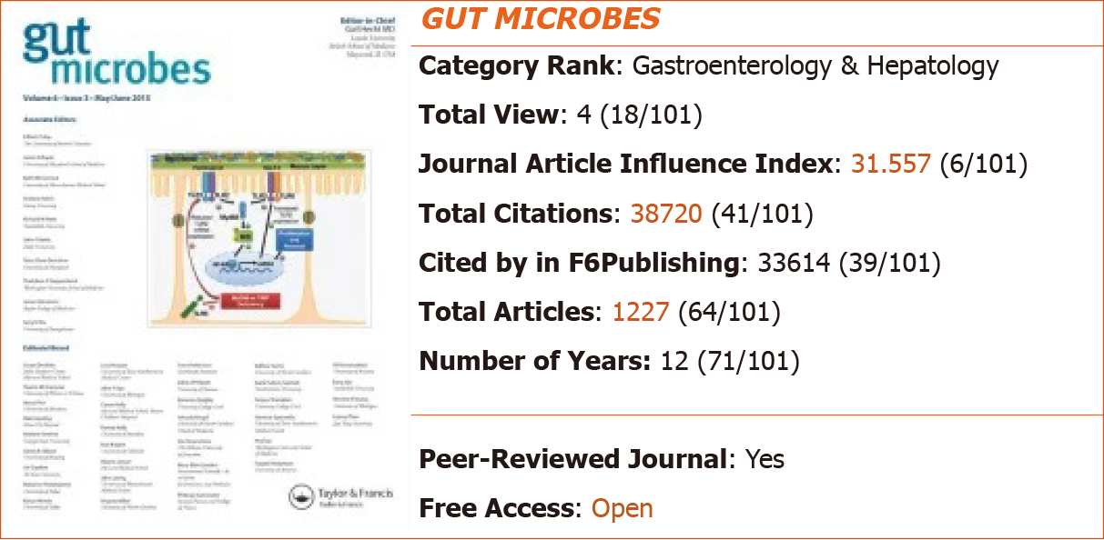
Figure 6 2022 Journal Article Influence Index and rankings of Gut Microbes.

2022 JAII and rankings of Alimentary Pharmacology & Therapeutics
In the RCA database, the 2022 JAII for Alimentary Pharmacology & Therapeutics is 28.725, ranking 7th among 101 core journals in the field of gastroenterology and hepatology included in the RCA, with total citations of 323707 (10/101) and total articles of 11269 (13/101) (Figure 7). For more information about Alimentary Pharmacology & Therapeutics, please visit: https://www.referencecitationanalysis.com/SearchJournal.
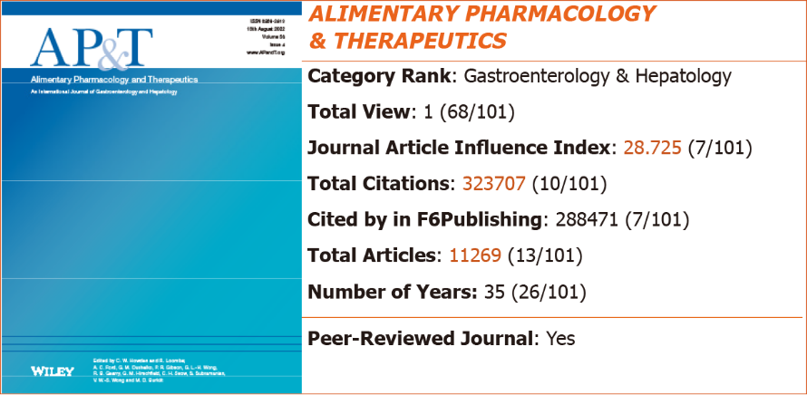
Figure 7 2022 Journal Article Influence Index and rankings of Alimentary Pharmacology & Therapeutics.

2022 JAII and rankings of Journal of Hepatology
In the RCA database, the 2022 JAII for Journal of Hepatology is 28.725, ranking 8th among 101 core journals in the field of gastroenterology and hepatology included in the RCA, with total citations of 556699 (4/101) and total articles of 19575 (7/101) (Figure 8). For more information about Journal of Hepatology, please visit: https://www.referencecitationanalysis.com/SearchJournal.
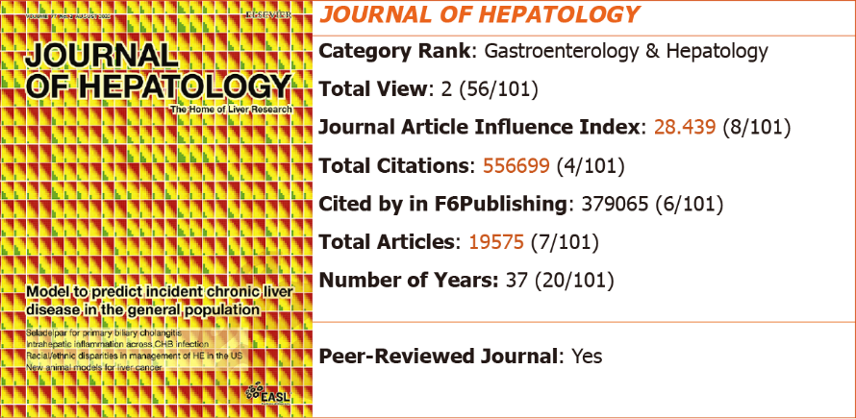
Figure 8 2022 Journal Article Influence Index and rankings of Journal of Hepatology.

2022 JAII and rankings of Best Practice & Research Clinical Gastroenterology
In the RCA database, the 2022 JAII for Best Practice & Research Clinical Gastroenterology is 28.428, ranking 9th among 101 core journals in the field of gastroenterology and hepatology included in the RCA, with total citations of 44917 (36/101) and total articles of 1580 (54/101) (Figure 9). For more information about Best Practice & Research Clinical Gastroenterology, please visit: https://www.referencecitationanalysis.com/SearchJournal.
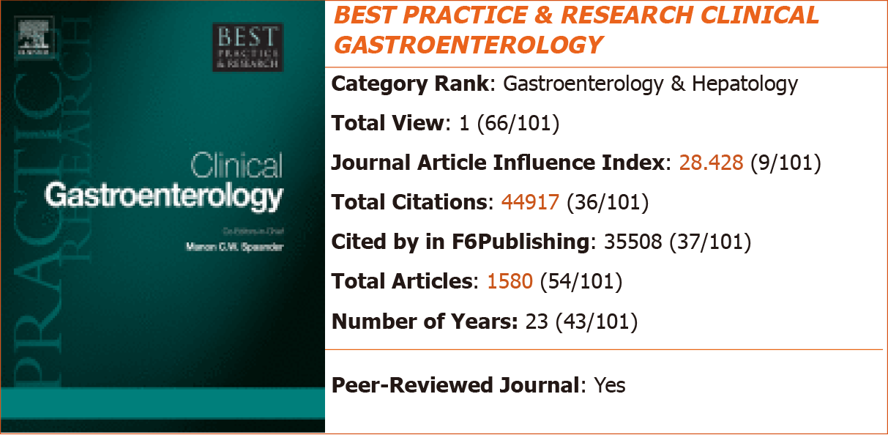
Figure 9 2022 Journal Article Influence Index and rankings of Best Practice & Research Clinical Gastroenterology.

2022 JAII and rankings of Diseases of the Colon & Rectum
In the RCA database, the 2022 JAII for Diseases of the Colon & Rectum is 26.946, ranking 10th among 101 core journals in the field of gastroenterology and hepatology included in the RCA, with total citations of 344714 (9/101) and total articles of 12793 (10/101) (Figure 10). For more information about Diseases of the Colon & Rectum, please visit: https://www.referencecitationanalysis.com/SearchJournal.
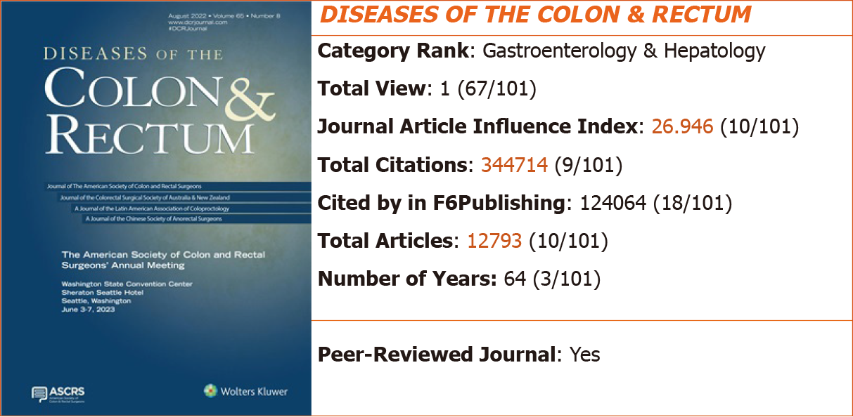
Figure 10 2022 Journal Article Influence Index and rankings of Diseases of the Colon & Rectum.

2022 JAII and rankings of Liver Transplantation
In the RCA database, the 2022 JAII for Liver Transplantation is 26.872, ranking 11th among 101 core journals in the field of gastroenterology and hepatology included in the RCA, with total citations of 159891 (18/101) and total articles of 5950 (25/101) (Figure 11). For more information about Liver Transplantation, please visit: https://www.referencecitationanalysis.com/SearchJournal.
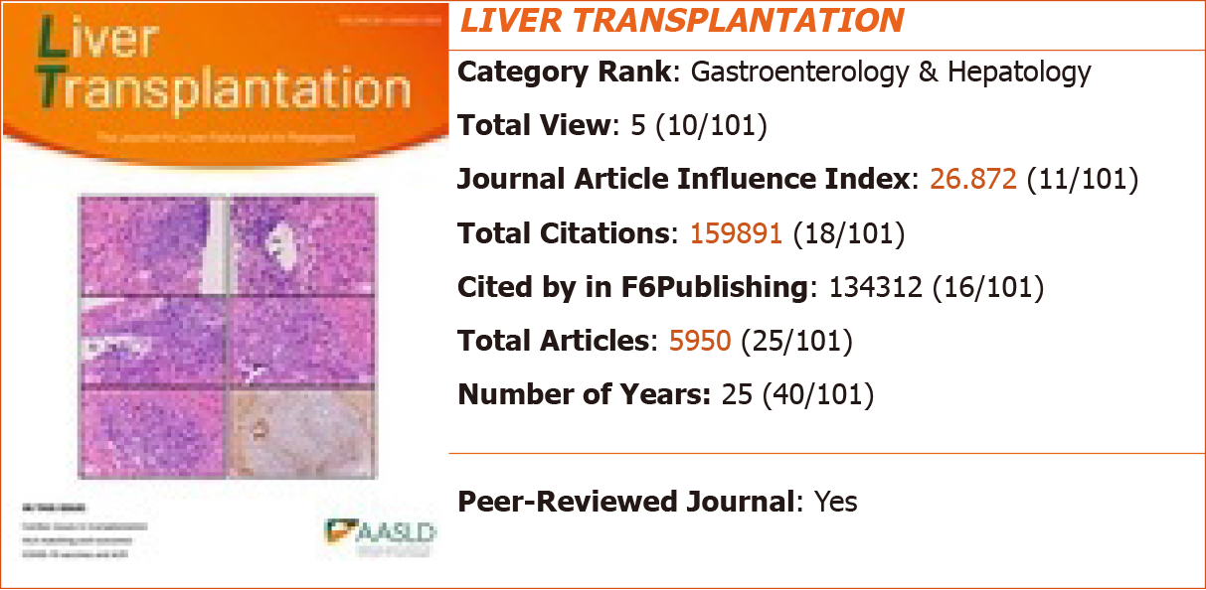
Figure 11 2022 Journal Article Influence Index and rankings of Liver Transplantation.

2022 JAII and rankings of Gastric Cancer
In the RCA database, the 2022 JAII for Gastric Cancer is 24.105, ranking 12th among 101 core journals in the field of gastroenterology and hepatology included in the RCA, with total citations of 45558 (35/101) and total articles of 1890 (49/101) (Figure 12). For more information about Gastric Cancer, please visit: https://www.referencecitationanalysis.com/SearchJournal.
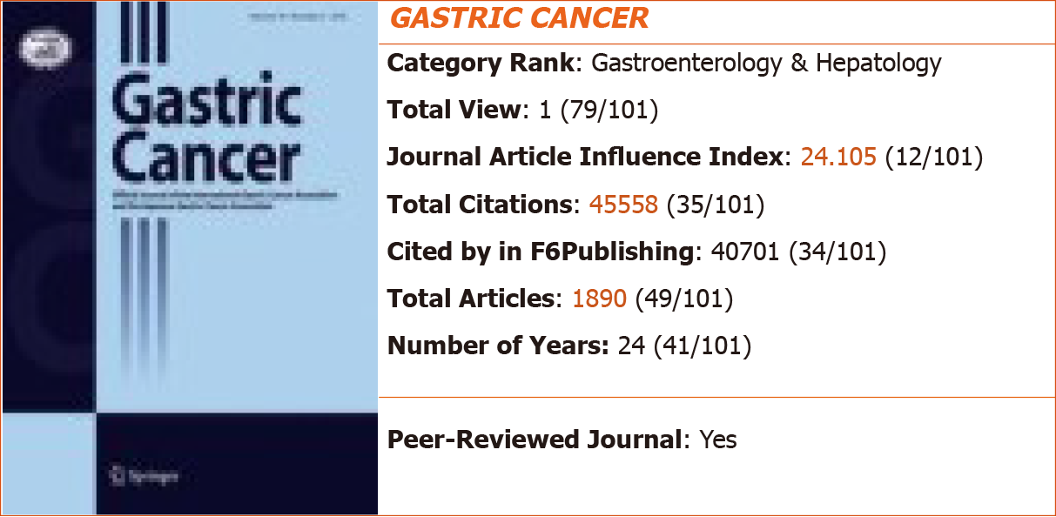
Figure 12 2022 Journal Article Influence Index and rankings of Gastric Cancer.

2022 JAII and rankings of The American Journal of Gastroenterology
In the RCA database, the 2022 JAII for The American Journal of Gastroenterology is 23.563, ranking 13th among 101 core journals in the field of gastroenterology and hepatology included in the RCA, with total citations of 476726 (5/101) and total articles of 20232 (6/101) (Figure 13). For more information about The American Journal of Gastroenterology, please visit: https://www.referencecitationanalysis.com/SearchJournal.
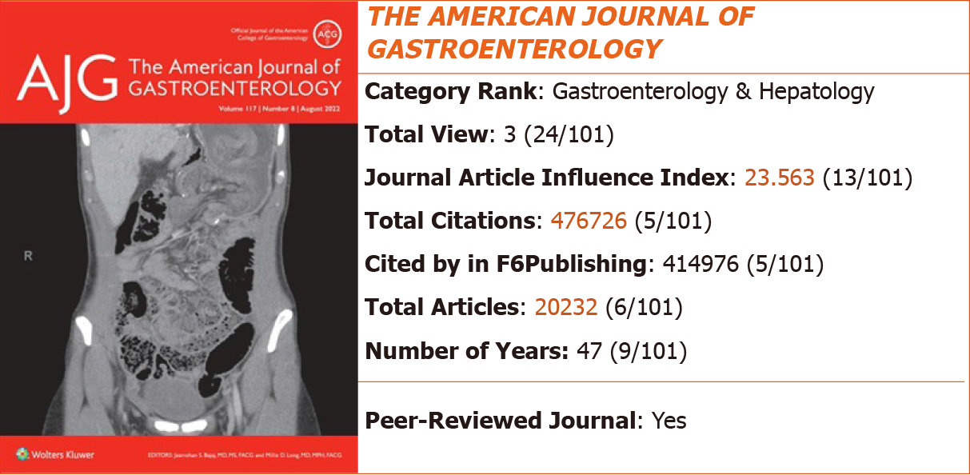
Figure 13 2022 Journal Article Influence Index and rankings of The American Journal of Gastroenterology.

2022 JAII and rankings of Lancet Gastroenterology & Hepatology
In the RCA database, the 2022 JAII for Lancet Gastroenterology & Hepatology is 23.470, ranking 14th among 101 core journals in the field of gastroenterology and hepatology included in the RCA, with total citations of 30276 (48/101) and total articles of 1290 (63/101) (Figure 14). For more information about Lancet Gastroenterology & Hepatology, please visit: https://www.referencecitationanalysis.com/SearchJournal.
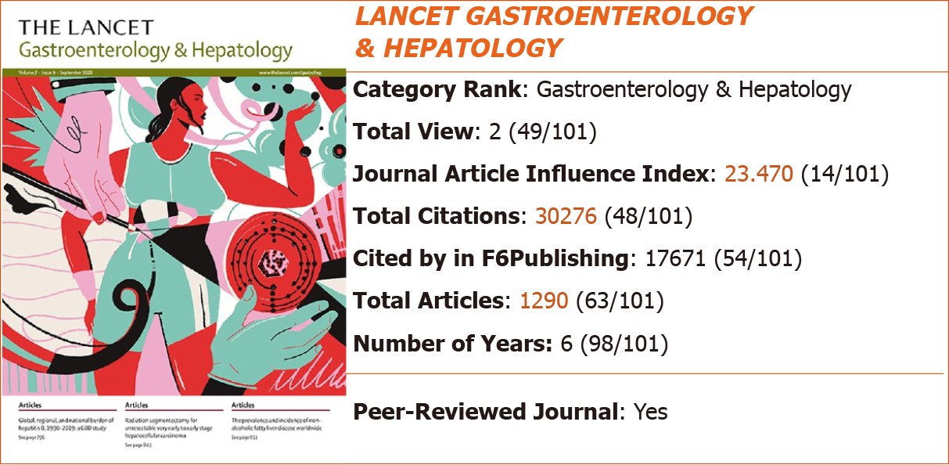
Figure 14 2022 Journal Article Influence Index and rankings of Lancet Gastroenterology & Hepatology.

2022 JAII and rankings of Journal of Gastroenterology
In the RCA database, the 2022 JAII for Journal of Gastroenterology is 22.837, ranking 15th among 101 core journals in the field of gastroenterology and hepatology included in the RCA, with total citations of 110941 (22/101) and total articles of 4858 (28/101) (Figure 15). For more information about Journal of Gastroenterology, please visit: https://www.referencecitationanalysis.com/SearchJournal.
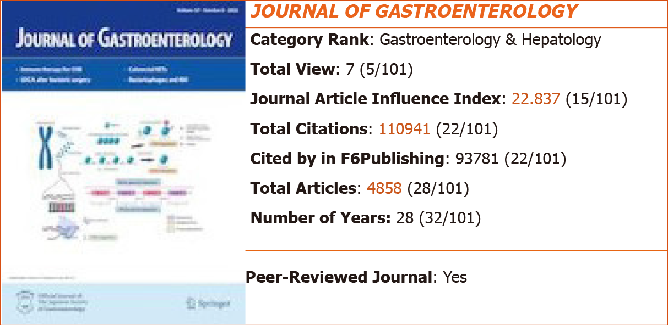
Figure 15 2022 Journal Article Influence Index and rankings of Journal of Gastroenterology.

2022 JAII and rankings of Neurogastroenterology and Motility
In the RCA database, the 2022 JAII for Neurogastroenterology and Motility is 22.335, ranking 16th among 101 core journals in the field of gastroenterology and hepatology included in the RCA, with total citations of 93695 (26/101) and total articles of 4195 (30/101) (Figure 16). For more information about Neurogastroenterology and Motility, please visit: https://www.referencecitationanalysis.com/SearchJournal.
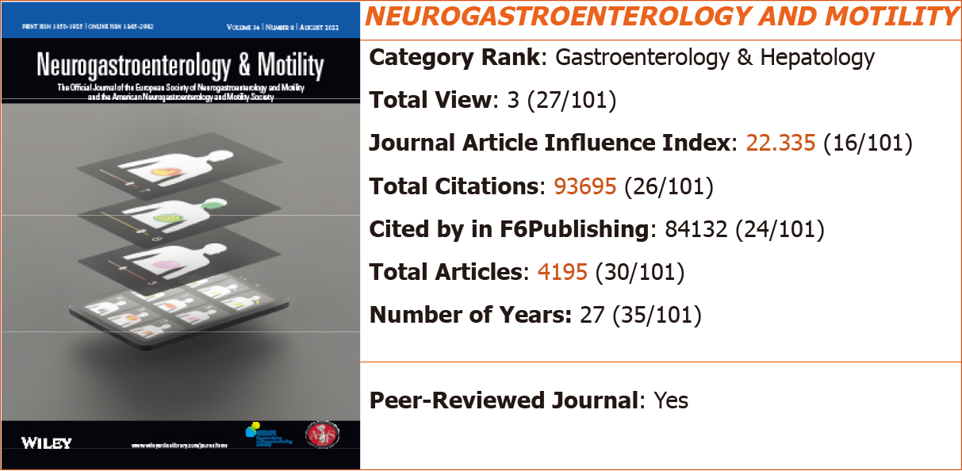
Figure 16 2022 Journal Article Influence Index and rankings of Neurogastroenterology and Motility.

2022 JAII and rankings of Clinical Gastroenterology and Hepatology
In the RCA database, the 2022 JAII for Clinical Gastroenterology and Hepatology is 22.295, ranking 17th among 101 core journals in the field of gastroenterology and hepatology included in the RCA, with total citations of 223108 (13/101) and total articles of 10007 (17/101) (Figure 17). For more information about Clinical Gastroenterology and Hepatology, please visit: https://www.referencecitationanalysis.com/SearchJournal.
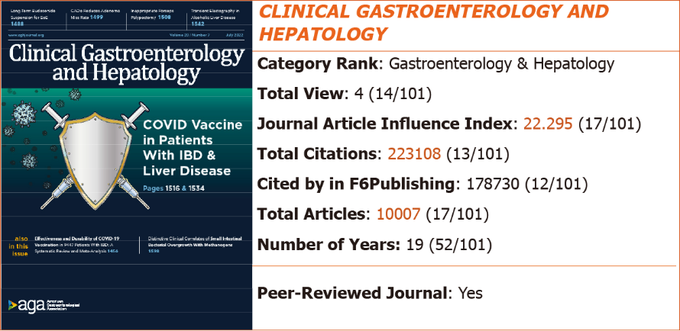
Figure 17 2022 Journal Article Influence Index and rankings of Clinical Gastroenterology and Hepatology.

2022 JAII and rankings of World Journal of Gastroenterology
In the RCA database, the 2022 JAII for World Journal of Gastroenterology is 21.914, ranking 18th among 101 core journals in the field of gastroenterology and hepatology included in the RCA, with total citations of 471463 (4/101) and total articles of 21514 (5/101) (Figure 18). For more information about World Journal of Gastroenterology, please visit: https://www.referencecitationanalysis.com/00000009.
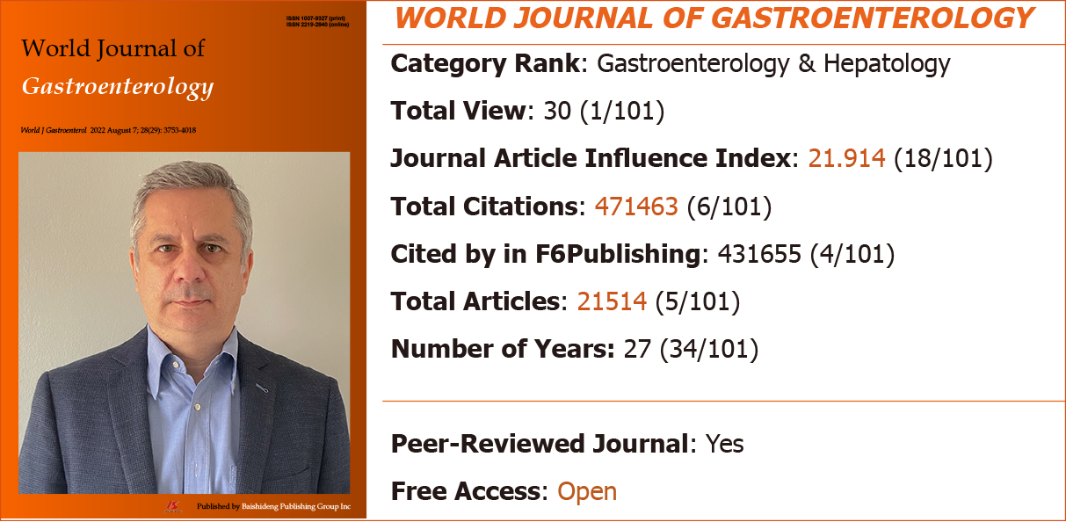
Figure 18 2022 Journal Article Influence Index and rankings of World Journal of Gastroenterology.

2022 JAII and rankings of American Journal of Physiology-Gastrointestinal and Liver Physiology
In the RCA database, the 2022 JAII for American Journal of Physiology-Gastrointestinal and Liver Physiology is 21.406, ranking 19th among 101 core journals in the field of gastroenterology and hepatology included in the RCA, with total citations of 230179 (11/101) and total articles of 10753 (14/101) (Figure 19). For more information about American Journal of Physiology-Gastrointestinal and Liver Physiology, please visit: https://www.referencecitationanalysis.com/SearchJournal.
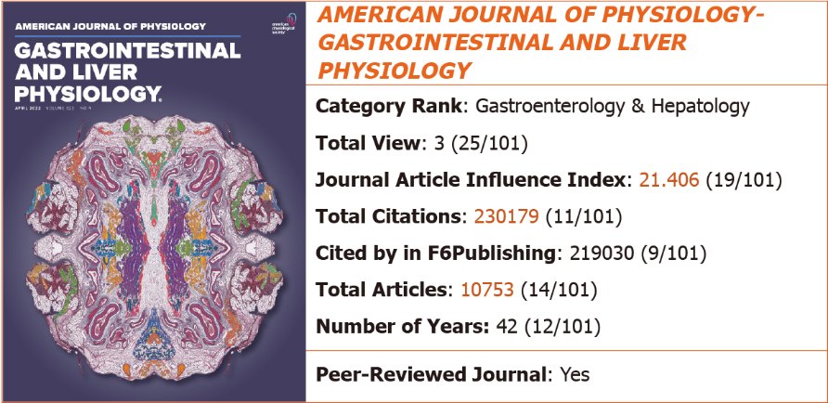
Figure 19 2022 Journal Article Influence Index and rankings of American Journal of Physiology-Gastrointestinal and Liver Physiology.

2022 JAII and rankings of Journal of Gastrointestinal Surgery
In the RCA database, the 2022 JAII for Journal of Gastrointestinal Surgery is 20.714, ranking 20th among 101 core journals in the field of gastroenterology and hepatology included in the RCA, with total citations of 138742 (20/101) and total articles of 6698 (22/101) (Figure 20). For more information about Journal of Gastrointestinal Surgery, please visit: https://www.referencecitationanalysis.com/SearchJournal.
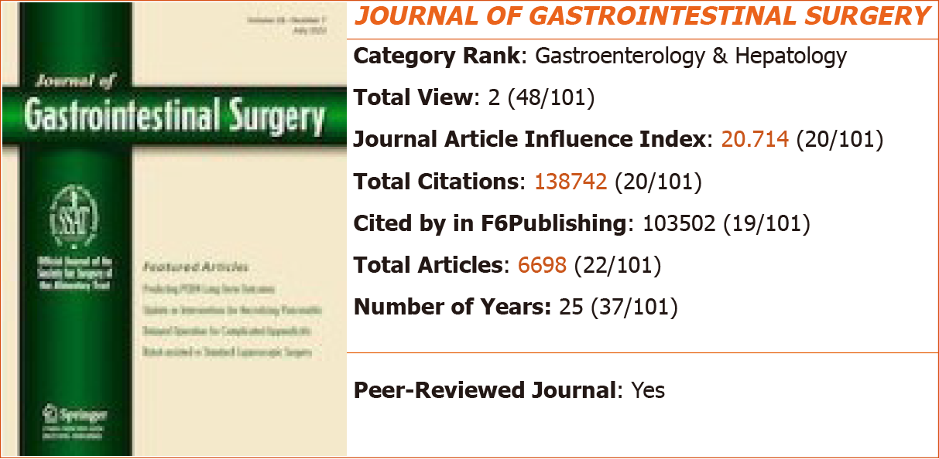
Figure 20 2022 Journal Article Influence Index and rankings of Journal of Gastrointestinal Surgery.

CALCULATION METHOD OF 2022 JAII
The 2022 JAII, calculated as Total citations/Total articles, is not a 2-year nor 5-year average of citations, but is an average of citations for all types of articles since the journal was assigned its DOI number. In this way, it is a more objective, fair, and transparent calculation of the academic influence index of an academic journal. Furthermore, the journal list itself is evaluated dynamically, its bibliographic metrics being updated daily, including total number of articles, total citations, and JAII.

EVALUATION PROCESS OF RCA JOURNALS
The journals included in the RCA core journal list need to undergo three rounds of strict evaluation. The evaluation process is as follows:

First-round evaluation: The basic information of the journal is verified, including Journal Name, Abbreviated Title, Print ISSN, Online ISSN, Language, Category, Peer-Reviewed Journal, Ownership, Publisher, Journal Website, Editorial Board Members, Submit a Manuscript, and Indexed by.

Second-round evaluation: The activity of the journal is verified, including Total Articles, Total Citations, Cited by in F6Publishing, and JAII.

Third-round evaluation: An open, objective, fair, and reliable list of core academic journals is created according to the discipline classification and based on the reliability of the collective Journal Information, activity of published data, Peer-Reviewed Journal, and JAII. The aim is to provide authors and readers with a reliable list of active academic journals, which will further enhance the credibility and brand effect of the included academic journals. The function of the list of core academic journals is to classify journals according to disciplines and rank them according to various bibliometrics, including Total Views, JAII, Total Citations, Cited by in F6Publishing, Total Articles, and Number of Years.

INCLUSION PRINCIPLES OF RCA JOURNAL
The RCA editorial team of Baishideng conducted three rounds of rigorous evaluation on core journals in gastroenterology and hepatology. The resultant RCA core journal list for the field of gastroenterology and hepatology includes a total of 101 journals, among which the highest 2022 JAII is 48.014 and the lowest JAII is 3.900, the highest total citations are 1711173 and the lowest are 698, and the highest total articles are 46037 and the lowest are 133. The RCA core journal list does not include any journals with a JAII lower than 3.0. We implement dynamic evaluation inclusively for the RCA core journal list. Evaluation is initiated once an RCA-nonincluded journal receives a JAII over 3.0. Similarly, if a journal included in the RCA core journal list receives a JAII lower than 3.0, it will be dropped out at that point. The RCA core journal list is designed by publishers, scientific editors, and engineers for use by readers, authors, and editorial offices, and is free-of-charge to users.
Upon completion of the three rounds of rigorous evaluation on core journals in gastroenterology and hepatology by the RCA editorial team, all data of each journal are organized for public consumption according to category rank, including 2022 JAII, total citations, cited by in F6Publishing, total articles, and 2021 Journal Impact Factor™. All journal information of each journal, including Journal Name, Print ISSN, Online ISSN, Language, Free Access, Peer-Reviewed Journal, Ownership, Publisher, Journal Website, Editorial Board Members, Submit a Manuscript, and Indexed by are made available in RCA. Moreover, the citations of each journal can be then ranked in RCA by the Impact Index Per Article, Cited by in Crossref, and Cited by in F6Publishing parameters. Results analysis available for each journal includes Year Published Analysis, Article Type Analysis, Journal Title Analysis, and Category Analysis. The references of each journal are also able to be refined by Year Published and Article Type. Each reference’s citation information is displayed, including PMID, DOI, Cited by in Crossref, Impact Index Per Article, Reference Citation Analysis, and Track Full Text.

CONCLUSION
The ultimate purpose of RCA is to provide an open, objective, fair, and reliable academic evaluation service platform for readers, authors, and journal editors. The RCA journal academic evaluation service platform is designed and actively maintained to address the needs of authors to select reliable journals for submission, readers to select high-quality literature for reading, and editors to track their own journal citation performance. The RCA core journal list itself will serve as a useful Find-a-Journal tool. Any interested party is welcome to use this journal list and recommend it to their peers.

REFERENCES
1 Baishideng Publishing Group Inc. Welcome to the Reference Citation Analysis. Available from: https://www.referencecitationanalysis.com

Footnotes
Conflict-of-interest statement: The authors are both employees of the Baishideng Publishing Group LLC and declare that they have no other real or potential conflicts of interest to disclose.

